Chapter 02: Introduction to SAP

Exercise 02-01: Introduction to SAP

Multiple Company Code

Version 4.12

Revised 8/8/2014

Introduction

General Notes and Information

It is strongly recommended that you read through the entire exercise prior to starting. Not all instructions can be provided in a linear manner in the exercise itself. READ CAREFULLY!

The following symbols are used to indicate important information as described below.

* An arrow highlights an important instruction that must not be overlooked.

🖉 A pencil prompts you to write down an important piece of information.

Each student or group will be assigned a unique two-digit identifier. This identifier is used in all exercises. Whenever you see ##, replace it with your identifier. For example, Joe may have an identifier of 05. Every time Joe sees the ## symbol, he will replace it with “05”.

* Always work with your data.

Business Process Overview

This exercise will help familiarize you with SAP. It will cover navigating in SAP, utilizing the search function, and some other basic functions that will prove useful when performing the rest of the exercises. If you are already familiar with SAP, it will be a nice refresher.

Exercise Prerequisites

There are no prerequisites needed.

Exercise Workflow

Exercise Deliverables

Deliverables are consolidated into one worksheet at the end of the exercise. It is only necessary to turn in that worksheet and that worksheet alone along with data in the system if required.

For this exercise you will need the following deliverables:

In the System:

* None

On Paper:

* Answer(s) to Question(s)
* You may be assigned additional deliverables. Make certain to check with your instructor.

Step 1: Navigating SAP

In this step, you begin to navigate SAP through the SAP menu. This menu contains all the functionalities of SAP. They are broken up according to business functions. Within all GBI exercises, a navigation path similar to the one below will guide you through the menu. This first exercise will show you how to view the accounts receivable balance for a customer.

1. In the “SAP Easy Access” screen, follow the navigation path below:

Navigation

Accounting 🡪 Financial Accounting 🡪 Accounts Receivable 🡪 Account 🡪 Display Balances

* To actually enter the transaction, double-click on Display Balances within the navigation.
* In later exercises you enter information within the fields. However, for this exercise, you do not enter any information. Instead, you view the displayed data within the system.
* Here, a customer’s identification number and two other pieces of information are entered to identify a customer’s accounts receivable balance for the specified fiscal year in the system.

1. You are now in the “Customer Balance Display” screen, now answer the following questions.
2. In the “Customer Balance Display” screen, what is the top field called?customer 🖉
3. What is the second field in the screen called?company code 🖉
4. What is the third field in the screen called?fiscal year 🖉
5. Click on  (EXIT).

* To exit using another option, type “/n” into the 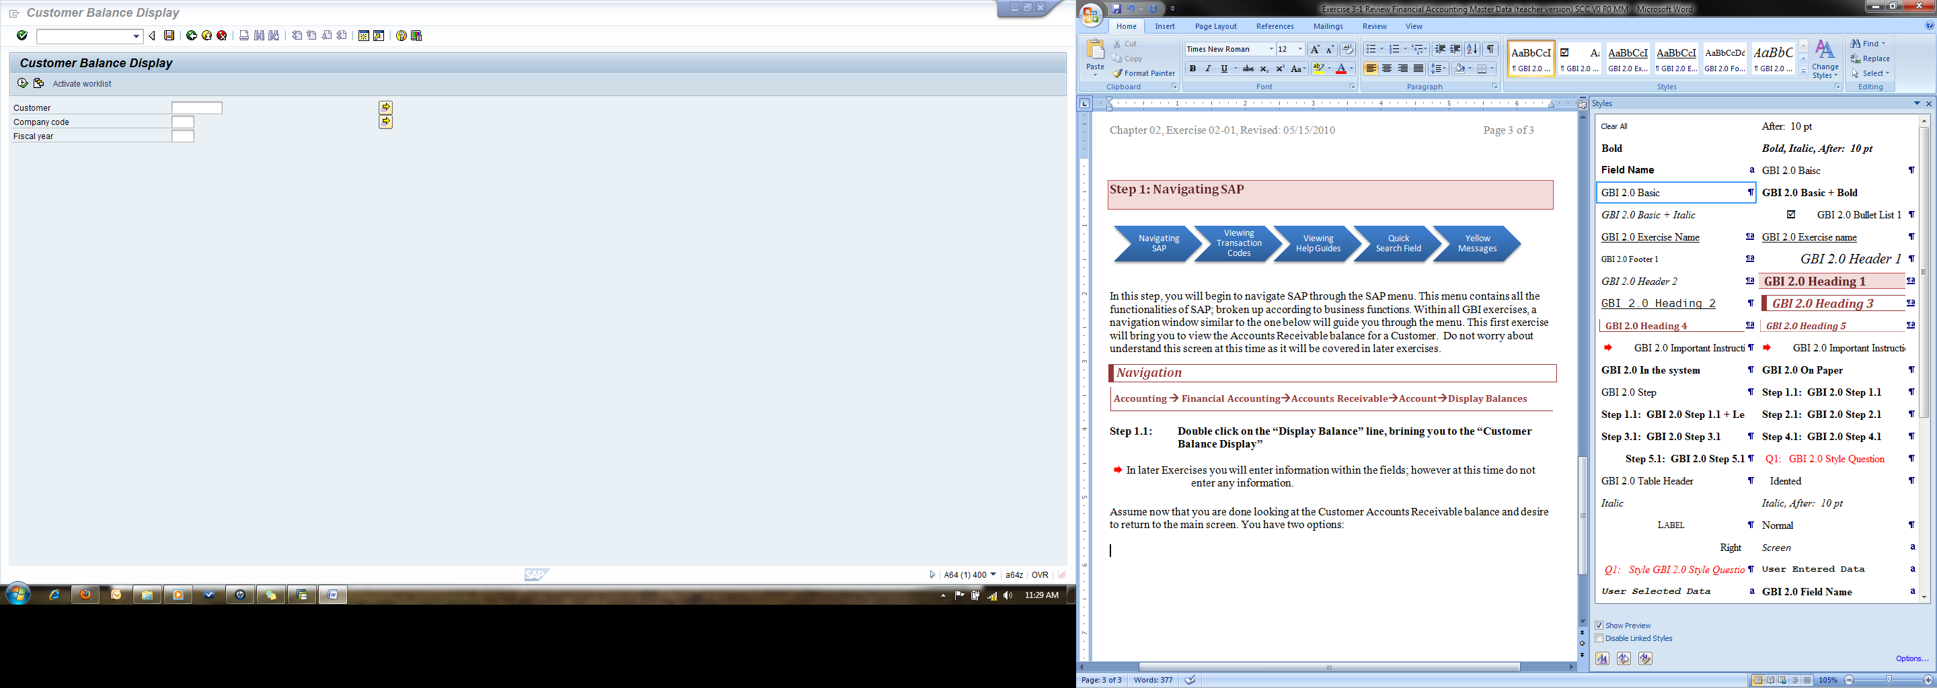 field at the top and click on the  icon. This will bring you back to the main screen that you started with.
* Don’t worry about memorizing anything in this screen at this time. This is in later exercises.

Exercise Deliverables

In the System:

* None

On Paper:

* Answer(s) to Question(s)

Step 2: Viewing Transaction Codes

In this step, you continue navigating through the SAP menu. However, instead of using the drop down menu, you will use transaction codes to pull up a specific window. In this step, you will learn how to find the transaction codes, how to use these codes, and how they work.

1. In the “SAP Easy Access” screen (at the top), click on Extras.
2. Click on Settings.
3. In the “Settings” pop-up, ensure that “Display technical names” is selected.
4. Click on  (CONTINUE (ENTER)).
5. In the “SAP Easy Access” screen, follow the navigation path below:

Navigation

Accounting 🡪 Financial Accounting 🡪 Accounts Receivable 🡪 Account 🡪 Display Balances

* DO NOT double-click on Display Balances.
* Before clicking on the line, notice additional information has been included before the name. This is the transaction code to enter to proceed to the “Customer Balance Display” screen.

1. What is the transaction code for the *“Customer Balance Display”* screen?FD10N 🖉
2. Click on 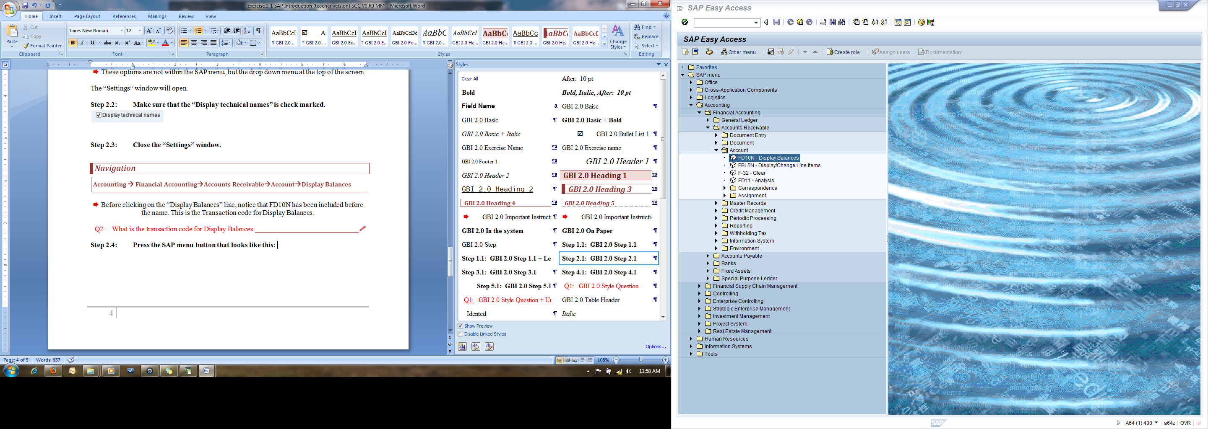 (SAP MENU).

* Pressing this button will return the SAP menu to the original status.

1. Type the transaction code in the  field and press on the “Enter” key to proceed to the “Customer Balance Display” screen).

Exercise Deliverables:

In the System:

* None

On Paper:

* Answer(s) to Question(s)

Step 3: Viewing Help Guides

In this step, you learn how to use the “Performance Assistant” tool to help you find answers to error messages or to find the definition or explanation of a field within the SAP system.

1. In the “SAP Easy Access” screen, follow the navigation path below:

Navigation

Accounting 🡪 Financial Accounting 🡪 Accounts Receivable 🡪 Account 🡪 Display Balances

1. In the “Customer Balance Display” screen, click on the “Customer” field.

* Do not enter any customer information in the field.

1. Press on the “F1” key on your keyboard.
2. What is the “Account Number” definition?A unique key used to clearly identify the customer within the SAP 🖉
3. In the “Performance Assistant” pop-up, click on the “Close” icon.
4. In the “Customer Balance Display” screen, click on the 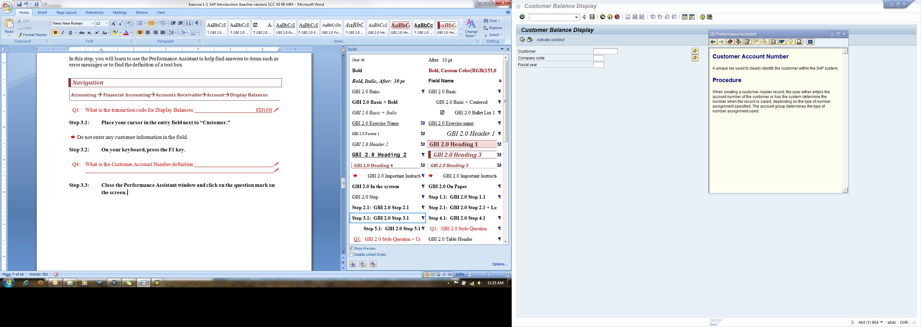 icon.

* Notice that by performing either one of these actions displays the “Assistant” tool.

Exercise Deliverables:

In the System:

* None

On Paper:

* Answer(s) to Question(s)

Step 4: SAP Search Menu

Before this step, you accessed the “Customer Balance Display” screen by navigating through the menu path and using a transaction code. In this step, you will learn how to use the SAP search menu. The search menu enables you to find a specific page by searching key words.

1. In the “SAP Easy Access” screen, type “search_sap_menu” in the command field.

* This is the field on the top-left of the screen.

1. Click on  (ENTER).
2. In the “Enter transaction code” pop-up, enter the following information:

|  |  |
| --- | --- |
| Field Name | Data Entry |
| Search text entry | Display Balances |

1. Click on  (CONTINUE (ENTER)).

* This will bring up another screen that will list all of the locations “Display Balances” appears in the SAP menu. Notice that you can access the same screen by using different transaction codes. The reason for this is that multiple job positions may have to access this information (accountants, sales representative, credit managers, etc.). The seventh on the list is the transaction code that you have used in this exercise thus far within the system.

1. What is the first transaction code if you use this to search “Material Master”?VE81 🖉

Exercise Deliverables:

* In the System:
* None

On Paper:

* Answer(s) to Question(s)

Attachment 1: Exercise Worksheet

Name: Pokuri Chaitanya Swaroop

Course and Section: OMIS 643

Identifier: GBI-033

Client:

1. In the “Customer Balance Display” screen, what is the top field called? customer 🖉
2. What is the second field in the screen called? company code 🖉
3. What is the third field in the screen called? fiscal year 🖉
4. What is the transaction code for the *“Customer Balance Display”* screen? FD10N 🖉
5. What is the “Account Number” definition? A unique key used to clearly identify the customer within the SAP 🖉
6. What is the first transaction code if you use this to search “Material Master”? VE81 🖉